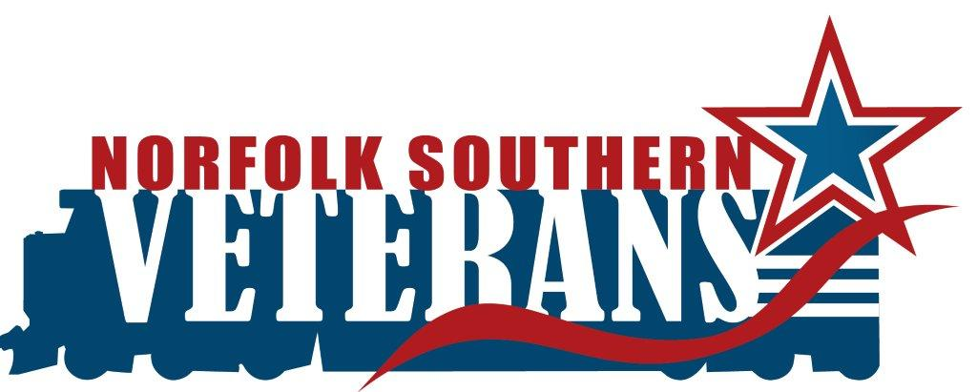

**REPRESENTATIVE’S NAME_________________________**

**CHILI NAME ____________________________________________________**

**CATEGORY_______________________**

**NS DEPARTMENT_____________________________**

**PHONE NUMBER ______________________________**

**_____________________________________________**

**E-MAIL _______________________________________**

**\*When:** Monday, November 11, 2013

**\*Time:** 11:00am-12:00pm

**\*Where:** Goode Building Lobby

**\*Applicants responsible for:** Your biggest pot of heated chili, crock pot or hot plate, extension cord, serving utensils, all table decorations, server. Electricity will be provided. “Open Flames” are PROHIBITED.

**\*Provided by VeteraNS:** table, testing cups, spoons and bowls for the public, ballet box, plastic gloves, hair nets and hand sanitizer to contestants.

**Hats can be substituted for hair nets**

**Space is limited enter early**

**Be creative with table decorations**

**Please complete form and send to** [**Veterans@nscorp.com**](mailto:Veterans@nscorp.com)

**Before 5PM on November 4, 2013**

*Form can also be scanned and emailed to [VeteraNS@nscorp.com](mailto:VeteraNS@nscorp.com)*

*Applicants will receive a confirmation email*

**For further information refer to attached VeteraNS Cook off Rules**